Vision

Our Trust’s vision rooted in John 10:10 that “I have come that they might have life, life in all its fullness “overarches everything we do as a family of schools. Enabling, nurturing, and celebrating all of our children’s achievements.
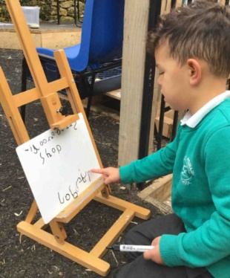  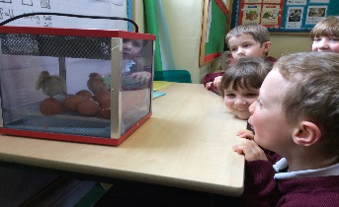  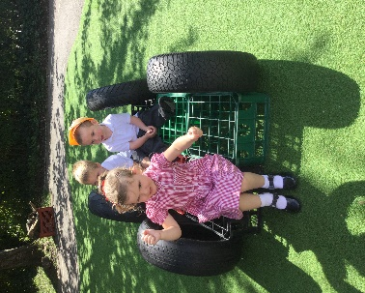 | Unique Child | Positive Relationships | Enabling Environments | 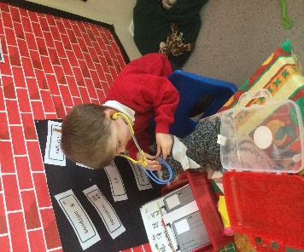  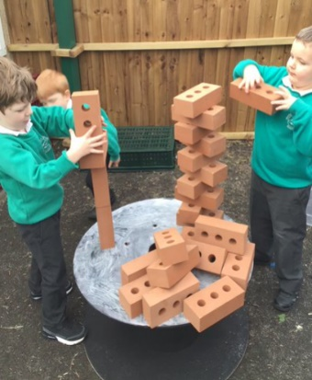  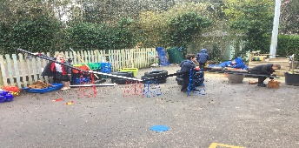
 | Children will have a strong sense of belonging and will feel part of a community that provides a starting point for their learning journey.  An inclusive, sequenced, creative and ambitious curriculum will ensure that the needs and interests of every child will be met through child led and adult focussed learning.  Children’s learning in all areas of the curriculum is nurtured and their achievements are celebrated.  Children are encouraged to develop independence, resilience and self-regulate in a safe learning environment.  In all aspects of the setting, adults will ensure that children are given opportunities to explore, be curious and imaginative in their play.  Transitions in and out of Early Years settings will ensure a continuum of learning for all children. | Adults take time to know and understand their children well.  Children will feel happy, safe, secure and valued for the unique and wonderful individuals they are.  Children make warm, nurturing and affirming relationships with their peers and familiar adults.  All adult interactions with children, during planned and child-initiated play and activities, will consistently support learning and development.  Interactions will include communicating and modelling language, scaffolding learning, exploring ideas, questioning to ensure depth of understanding, providing narratives, facilitating and challenging where appropriate. | Children will show high levels of motivation and engagement in their child led and adult focused learning in the indoor and outdoor classroom.  A language rich environment supports the teaching and consolidation of new skills and knowledge in order for learning to “stick”.  The environment supports the development of the characteristics of effective learning and reflects the uniqueness of each child and their journey.  Continuous provision is carefully planned and presented to children in order for them to become familiar with key basic resources that are used across the year.  Diverse resources are carefully selected to inspire, promote interest, and create awe and wonder, as well as encouraging consolidation of key skills and knowledge.  Children will take responsibility for their environment and demonstrate understanding of how to respect and value their world.
 | Parental Partnerships
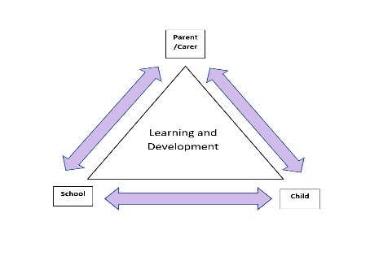

Through developing strong relationships and effective communication, all parents and carers will be valued as partners in their child’s learning journey.

