17 June 2020

Dear Parents and Carers
I am writing once again to thank you from The Diocese of Gloucester Academies Trust (DGAT), of which your child’s school is part, for the support you are providing your child/ren’s school with at this tricky time. Staff in all 17 of our schools are working hard to provide for children, both in school and at home. It is not an ideal situation for anyone, but we are trying to work through it as positively as we can.

I am also writing to let you know about some changes that are likely to be occurring before the end of term. Although the government has decided it is not possible to fulfill their ambition of having all children back in for a month before the summer holidays, as a Trust we feel it is important to have seen as many of our children before the summer as possible. This is because if we do not, some children will have been out of a school environment for six months if we return in September. We recognise that this may cause children to be anxious and worry about returning. We know that many of them are missing being with other children and seeing the staff.

What each school decides to do may vary, as our 17 schools are very different in terms of numbers of children, school building and staffing, but all Headteachers will be working to the same principle. This is to offer the year groups that have not been in school as yet, at least one session to come back to catch up with their friends, the staff and see how the school building is operating.

In some of our schools this may mean that right at the end of term (in the last week or two) children in the year groups who have already had time in school may not be able to attend. This is to make space for those children have had no time in school since March. While I appreciate that this may be disappointing if your child does not have a place, I’m sure you will understand that other parents have had no provision at all in school. There is not a solution where all children can be back in school at the same time and observe the strict infection control measures in place. Please note that current key worker and vulnerable children places will not be affected, and these children will come into school right until the term ends.

Your children’s school will be contacting you to let you know what provision will look like and explaining how it will work but I hope this letter helps you to understand why and put it into context.

If after seeing the provision offered you have concerns, please contact me at dgat@glosdioc.org.uk.

With best wishes

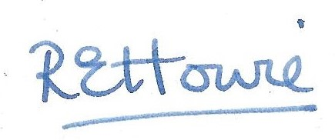

Mrs Rachel Howie
Chief Executive Officer

